**ONEline Auctions:**

User’s Manual

**TABLE OF CONTENTS**

Page Number

1.0 LoginGUI 3

1.1 No Input Error 3

1.2 Invalid Password 4

1.3 Invalid Username 4

1.4 Successful Login 5

2.0 RegisterGUI 5

2.1 No Input Error 6

2.2 User Already Exists 6

2.3 Passwords Don't Match 7

2.4 Account Creation Successful 7

3.0 SearchSelectionGUI 8

3.1 No Checkboxes Selected 9

3.2 No Search Matches Found 9

4.0 DisplayGUI 9,10,11



**1.0** LoginGUI:



Once the ONEline software is run, a login window pops up. This window asks the user to input their username and password in order to connect to our database. This is what the window looks like:

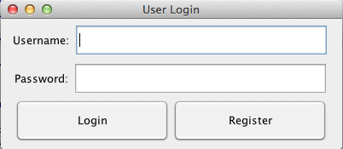

If the user has an account already created, he/she may enter their information to login. Enter the username in the top text box, and enter the password in the second text box. Then log in either by clicking the “Login” button, or buy pressing the “Enter” or “Return” key on the keyboard.



**1.1** LoginGUI No Input:



If the user accidentally clicks “Login”, or presses “Enter” on the keyboard, and no information was entered, they will see the following error message:

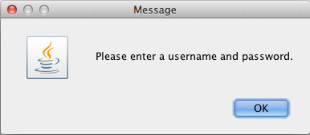

Click “OK” or press “Enter”, and the user will be returned to the original login screen. Simply enter the account information and try again.



**1.2** LoginGUI Invalid Password



If the user incorrectly enters his/her password, they will get this error message:

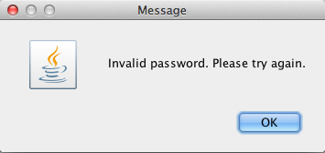

Click “OK” or press “Enter”, and the user will be returned to the original login screen. Simply try again by re-typing in the correct password.



**1.3** LoginGUI Invalid Username:



If the user incorrectly enters his/her username, they will get this error message:

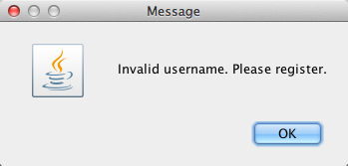

Click “OK” or press “Enter”, and the user will be returned to the original login screen. Simply try again by re-typing in a valid username. If one does not yet have an account, they can click the “Register” button from the login window.



**1.4** LoginGUI Successful Login:



Upon entering valid account information into the login screen, the user will see the following message once they click the “Login” button:

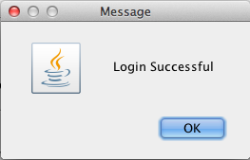

This informs the user that they have successfully logged in. They will then be able to use ONEline’s auction search from the search and display windows that appear.



**2.0** RegisterGUI:



If a user has not yet registered with our software, he/she may sign up by selecting the “Register” button from the login window. Once they do, this window will appear:

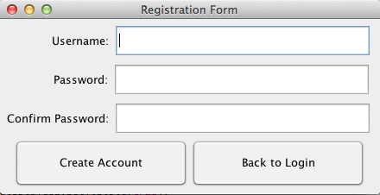This registration form will allow the user to register with our software. Simply enter in a desired username into the first text box, a password into the second textbox, and re-enter your same password into the third textbox to confirm that the passwords match.



**2.1** RegisterGUI No Input Error:



If the user fails to input any information, if they accidentally click the “Register” button, or if they accidentally hit the “Enter” button before any information is entered, they will see the following error message:

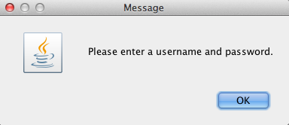

Upon clicking “OK”, the user will be returned to the registration form, allowing them to fill in the necessary information to create an account with our software.



**2.2** RegisterGUI Username Already Exists:



If the user entered a username that already exists within our system, they will receive the following error message:

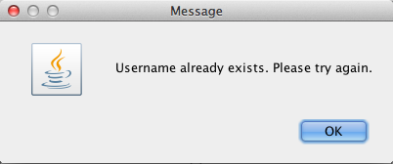

Click “OK” or press “Enter”, and the user will be returned to the registration form.

The user must enter a different username to register with our software. Simply do so by typing in a different username.



**2.3** RegisterGUI Passwords Don’t Match:



If the user attempts to register an account, but the password entered in the “Password” textbox does not match the password entered in the “Confirm Password” textbox, the user will see the following error message:

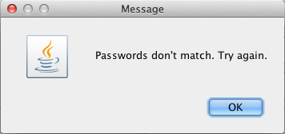

Click “OK” or press “Enter”, and the user will be returned to the registration form.

The user must re-enter both passwords to ensure that they are correct and matching.



**2.4** RegisterGUI Account Creation Successful:



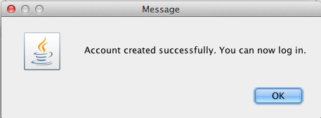If the user enters a valid and untaken username, as well as enters two matching passwords, they will be able to register. Upon successful registration, they will see this message displayed:

Upon clicking “OK”, the user will then be returned to the login screen in order to properly log into ONEline’s software.



**3.0** SearchSelectionGUI:



Once the user has successfully logged in, two windows will be displayed, one of which the following:

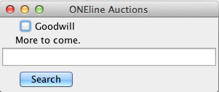

This is our search window. This window will allow the user to select which websites he/she would like to search auctions on. For example, here is a user searching for watches on Goodwill’s auction site:

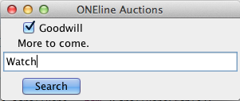

Simply click the “Search” button, or press “Enter”, and the resulting auctions will be updated within the database, and displayed onto our display window. THIS MAY TAKE SEVERAL SECONDS DEPENDING ON THE NUMBER OF RESULTS.



**3.1** SearchSelectionGUI: No Checkboxes Selected:



If the user failed to specify which websites he/she was searching, they will receive the following error message:

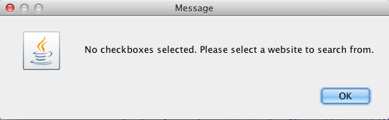Once the user clicks “OK”, they will be returned to the search window. The user must then select and click each website checkbox that they would like to search from.



**3.2** SearchSelectionGUI: No Search Matches Found:



If the user searches for a keyword, and there are no matching auctions available, they will receive the following error message:

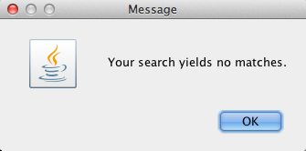

The user should modify their search (usually to something less specific) to see if there are any other auctions that are similar to what he/she is looking for.



**4.0** DisplayGUI:



Once the user has successfully logged in, two windows will be displayed. The display window will look like the following:

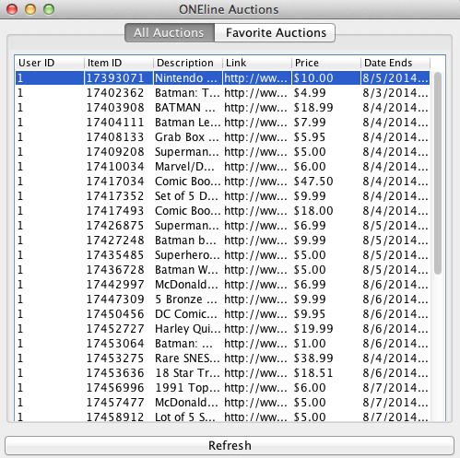

This is the window that displays ALL of the user’s auctions. The user can double click any auction and “favorite”, or save the auction for later viewing. To view these saved auctions, simply click the “Favorite Auctions” tab at the top of the window. This will change the window to display only the saved auctions, for example:

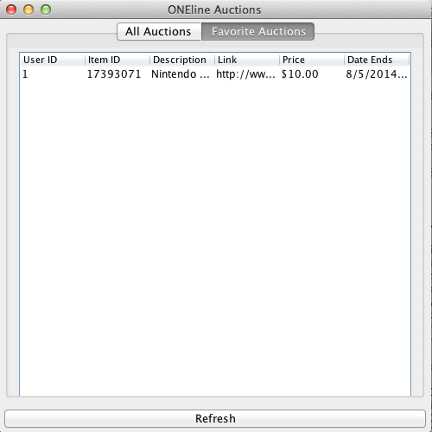To view these new “favorite” auctions, simply press the “Refresh” button at the bottom of the window.